|  |  |  |
| --- | --- | --- |
| Nombre:  ♦ Rodrigo Jara Espinoza  Código:  ♦ 20224280 | | NOTA: |
| FECHA: 11/06/2024 | SECC: 524 | |

**LABORATORIO 3_Plantilla**

# Problemas a resolver

**Ejercicio 1**

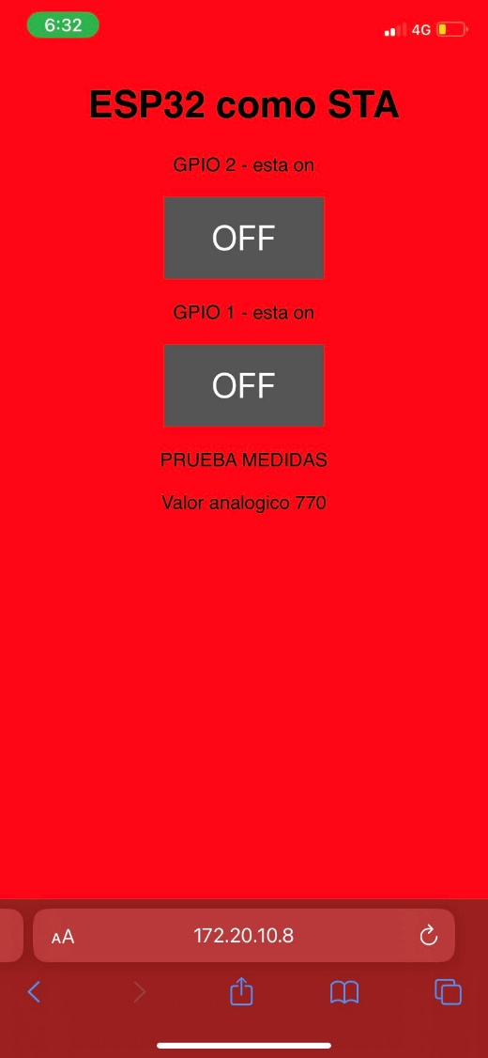

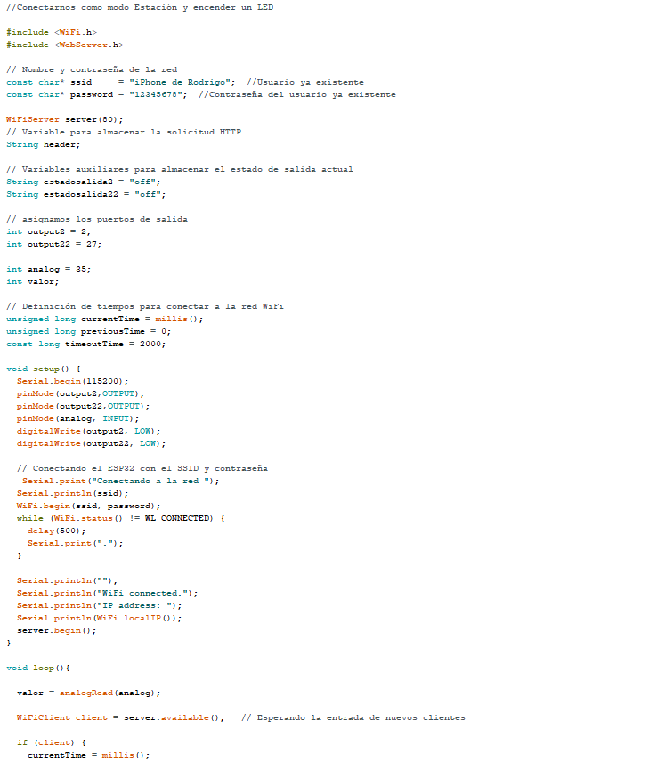

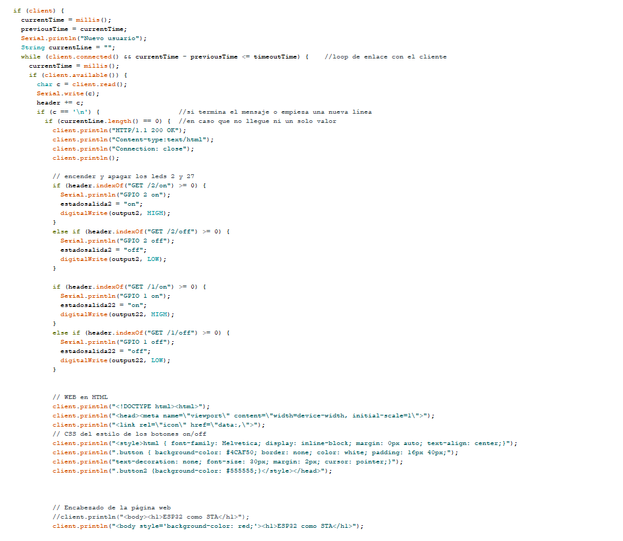

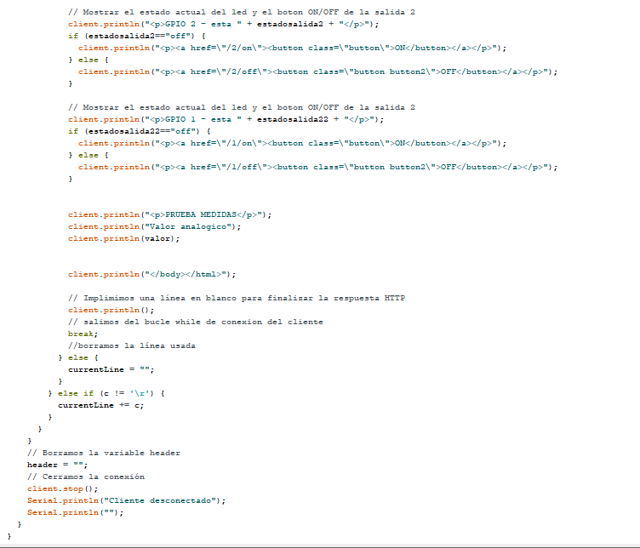

**Ejercicio 2**

Link: <https://thingspeak.com/channels/2575205>

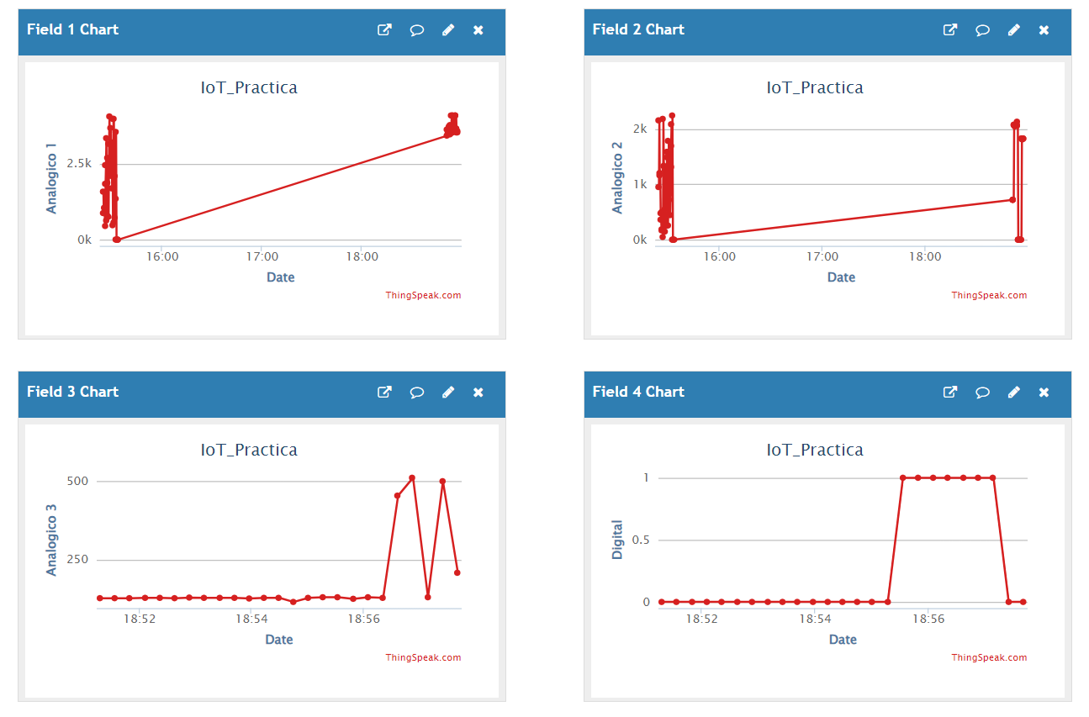

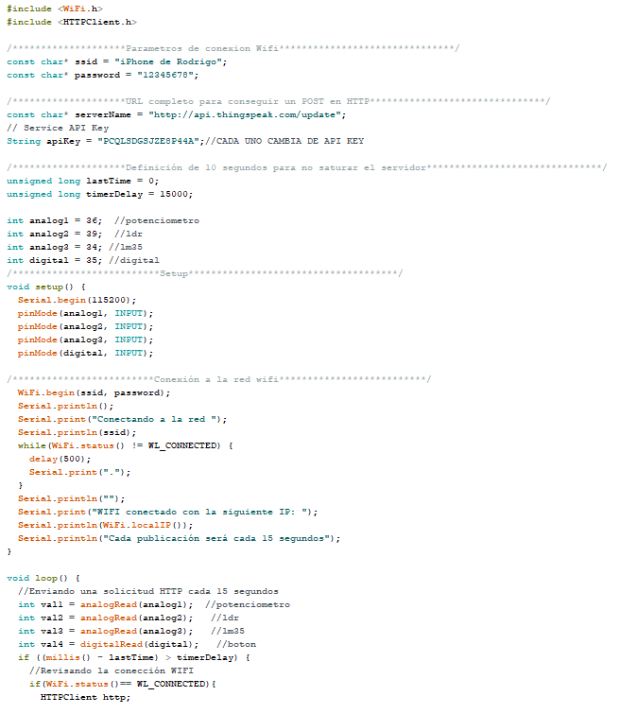

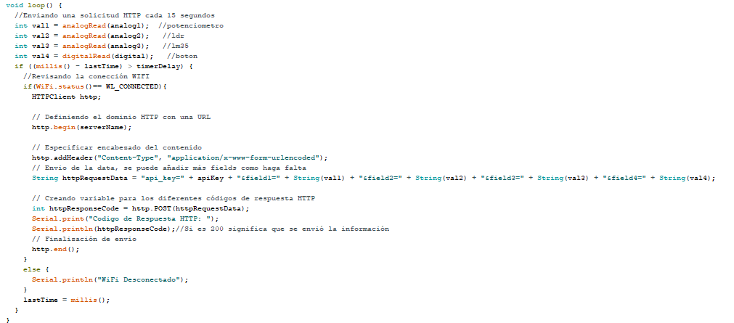

**Ejercicio 3**

Link: <https://io.adafruit.com/RodrigoJ/dashboards/iot-lab3>

